Figure 1.Area and distribution of pine forest plantations throughout Brazil (ABRAF, 2013). Acronyms: AP- Amapá; TO- Tocantins; BA- Bahia; MG- Minas Gerais; GO- Goiás; MS- Mato Grasso do Sul; ES- Espírito Santo; SP- São Paulo; PR- Paraná; SC- Santa Catarina; RS- Rio Grande do Sul.
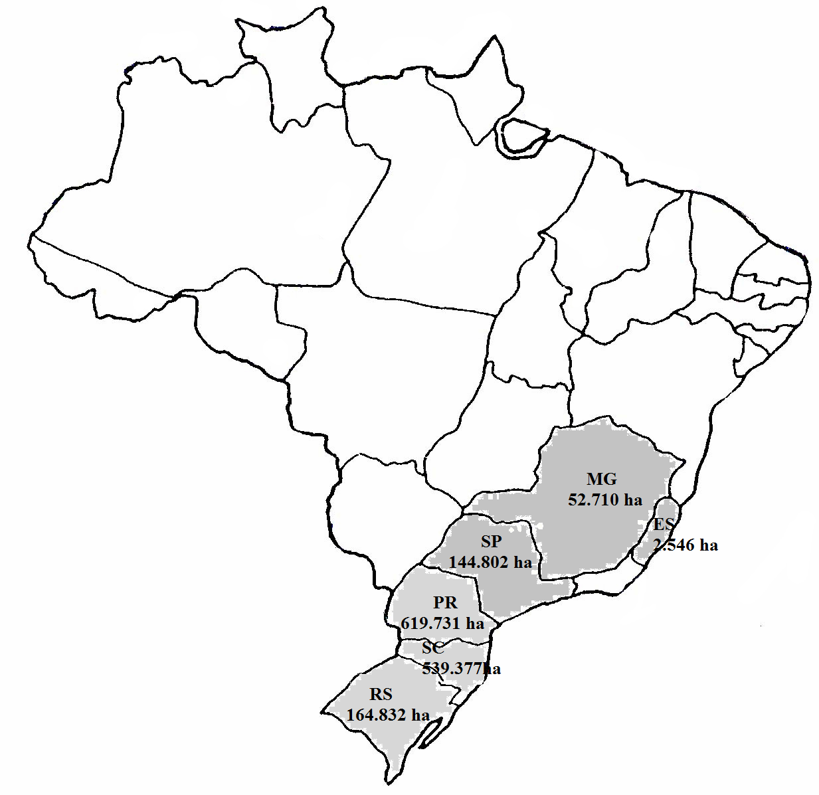

Figure 2. Flowchart and system boundaries corresponding to the Brazilian pine roundwood production system. Subsystem acronyms: SS1- Soil preparation; SS2- Seedlings plantation; SS3- Forest management; SS4- Forest harvesting; SS5- Infrastructure establishment.

Figure 3.Contributions to the environmental profile corresponding to the Brazilian pine roundwood production system considering current forest practices. Acronyms: SS1: Soil preparation; SS2- Seedlings plantation;SS3- Forest management; SS4- Forest harvesting; SS5- Infrastructure establishment; CC- Climate Change; OD –Ozone Depletion, TA- Terrestrial Acidification, FE- Freshwater Eutrophication, ME- Marine Eutrophication, HT- Human Toxicity, POF- Photochemical Oxidants Formation, TET- Terrestrial Ecotoxicity, FET- Freshwater Ecotoxicity, MET- Marine Ecotoxicity; WD- Water Depletion; FD- Fossil Depletion.

Figure 4. Distribution of impacts per processes involved in each subsystem. a) Soil preparation (SS1); b) Seedlings plantation (SS2); c) Forest management (SS3); d) Forest harvesting (SS4); e) Infrastructure establishment (SS5). Acronyms: CC- Climate Change; OD - Ozone Depletion, TA- Terrestrial Acidification, FE- Freshwater Eutrophication, ME- Marine Eutrophication, HT- Human Toxicity, POF- Photochemical Oxidants Formation, TET- Terrestrial Ecotoxicity, FET- Freshwater Ecotoxicity, MET- Marine Ecotoxicity; WD- Water Depletion; FD- Fossil Depletion.
(a)
(b)

Figure 4 (cont.).Distribution of impacts per processes involved in each subsystem. a) Soil preparation (SS1); b) Seedlings plantation (SS2); c) Forest management (SS3); d) Forest harvesting (SS4); e) Infrastructure establishment (SS5). Acronyms: CC- Climate Change; OD –Ozone Depletion, TA- Terrestrial Acidification, FE- Freshwater Eutrophication, ME- Marine Eutrophication, HT- Human Toxicity, POF- Photochemical Oxidants Formation, TET- Terrestrial Ecotoxicity, FET- Freshwater Ecotoxicity, MET- Marine Ecotoxicity; WD- Water Depletion; FD- Fossil Depletion.
(c)
(d)

Figure 4 (cont.). Distribution of impacts per processes involved in each subsystem. a) Soil preparation (SS1); b) Seedlings plantation (SS2); c) Forest management (SS3); d) Forest harvesting (SS4); e) Infrastructure establishment (SS5). Acronyms: CC- Climate Change; OD –Ozone Depletion, TA- Terrestrial Acidification, FE- Freshwater Eutrophication, ME- Marine Eutrophication, HT- Human Toxicity, POF- Photochemical Oxidants Formation, TET- Terrestrial Ecotoxicity, FET- Freshwater Ecotoxicity, MET- Marine Ecotoxicity; WD- Water Depletion; FD- Fossil Depletion.
(e)

